Enacting & Enchanting Assessment in Mathematics Teacher Education through Speculative Duo/ethnography.

Stéphanie La France
University of British Columbia, Canada
stephlaf@student.ubc.ca

Steven Khan
Brock University, Canada
skhan6@brocku.ca

Abstract
In this paper, we consider multiple sites of disenchantment and re-enchantment in assessment practice through the use of dialogue, reflection and speculative writing. We contend that this reflexive speculative approach enables us to dream first and negotiate later our future assessment practices. We argue that assessment systems in teacher education are part of a plantation infrastructure and discuss the many ways in which current standards of assessment in teacher education are disenchanting. These disenchantments lay the groundwork for the use of a speculative approach in provoking more positively daring imaginations for assessment. We present our tripartite fractal model for assessment practice, viz., holism, multiplicity and shared responsibility, as an example of re-enchantment.

Telling Stories
Assessment is one of those things that we had to start figuring out the day we started our formal schooling…. I figured out quickly that testing did not consider my prior cultural knowledge; it was irrelevant -Noella Steinhauer (Steinhauer et al., 2020, pp.78-79)
In the above quotation, Steinhauer reflects a common sentiment among students and educators as they navigate assessment. There is a deep (in)tensionality implicit in assessment practice. We draw on the work of Cree scholar Dwayne Donald (2020) who suggests that pedagogy relates to how we tell stories and why we tell them that way, while curriculum is about understanding the specific types of humans and humanity that we value. A distinction can be made between assessment methods, which are typically considered within discussions of pedagogy, and assessment practice, which is typically considered part of curriculum. Using Donald’s analogy, we frame assessment methods as the stories we tell, and assessment practice as the communication of that which is valued. In re-conceptualizing assessment frameworks for pre-service teachers, we must attend to understanding the specific types of life that we value, as well as the stories we tell about that life so that we might disrupt the disenchantment with assessment.
This article engages with and through the telling of stories. We reflect on stories of assessment as we have framed methods and practice above using a combination of duo/ethnography and speculative fiction (SF). Consider ‘with’ (SF) and ‘through’ (duo/ethnography) as two layers of storytelling. Given the nature of this piece, we begin with a discussion of how we use duo/ethnography and SF together suggesting possible affordances of this approach in research on assessment. We will follow this discussion by unpacking assessment as a fundamental part of education that can disenchant or re-enchant. Taking the stance of re-enchantment, we present a framework for assessment practice with examples from pre-service teacher education to follow.

Through the telling of stories: Duo/ethnography and speculative fiction
We offer a combined method using both SF and duo/autoethnography. Where duo/ethnography offers a critical lens for contemplating the past and present with inquiry partners, speculative fiction uses a ‘purposeful’ muddling of certain realities to imagine alternative futures.

Duo/ethnography
We use duo/ethnography as a conversational genre of story telling drawing from autoethnography’s situating of the self in relation to a particular cultural, social and/or political context to explore different variations and combinations of self (auto), culture (ethno) and process (graphy) (Ellis, 2012). In this paper, the ‘graphy’ is the landscape of assessment and the ‘ethno’ encompasses the relevant cultural implications. We include our ‘auto’ narratives in dialogue to produce a duo/ethnography (Norris et al, 2012) which allows us to story our memories and hopes through conversation. This methodology is well-established in mathematics education research (eg. Zaskis & Koichu, 2015). Duo/ethnography elicits an excavation of current and future assessment practices providing a self- and duo-reflexive landscape from which to speculate on promising futures.

Speculative fiction
SF is a genre of writing and research that functions to re-imagine, re-envision, and re-frame a context or phenomenon of interest (Thomas, 2013; Truman, 2021). The genre varies widely in the way it is employed but always aims to challenge consensus reality (Oziewicz, 2017). Truman uses speculative methodologies to unsettle humanisms which is part of an ongoing tradition of speculative and futurist writers, artists, sonicians, storytellers, and healers belonging to various communities. SF writers “are departing from and building in their own assumptions, criticisms, and idealizations of how the world works and of how it might be different” (Passell, 2013, p. 60).
SF in plays with estrangement and familiarity that is exploratory yet structured. Estrangement, here, means leaning into the unknown and defamiliarizing one’s own thinking. It involves imagining and engaging with peculiar realities that challenge taken-for-granted ‘truths’ (Brooker & Thomas, 2009; de Freitas & Truman, 2021) creating a story that is at once familiar yet strange. One might re-imagine a narrative that comments on the dystopian nature of reality (e.g., disenchantment) and/or suggests a promising alternative reality (e.g., re-enchantment).
We propose that SF can be an inquiry into the specific lives that are being valued and the specific stories that are told about those lives in mathematics education. According to Thorne (2021), speculative writing can be a strategy for inviting conversations around social justice and creating conditions for critical hope, for example, Afro and Indigenous futurisms (e.g., Alexander, 2019; Dillon & Marques, 2021). In extension, Alexander (2019) uses speculative writing as part of connecting Critical Race Theory and Afrofuturism to trouble the lack of engagement with Black mathematical futures.
SF scaffolds a dwelling in incomplete abstractions, which can be the starting point of inspiration and hope for better practices. It enables more daring and zealous explorations out of worlds that “might usher in a different world while simultaneously changing us: this is the power and potential of speculative thought and storying practices” (Truman, 2021, p. 7). The speculative approach suggests future-oriented multi-generational provocations that transcend multiple timelines making it an excellent fit for ethics-centred educational theorizing in mathematics education.
In combining SF and duo/autoethnography, we contend that this reflexive speculative approach enables us to ‘dream first and negotiate later’ as a micro move toward enchantment with assessment practices. We interleave speculative questions (SpecQ) for readers to engage with and believe that this work is timely as we continue to negotiate (in)tensions in practice that continue to act as disenchantments in practice.

Unpacking assessment
SpecQ1: What are the specific types of life that you value and what stories do you tell about that life?
There exist ‘types’ of life or ways of doing, being and knowing that we value in K–12 schooling and teacher education; correspondingly, there exist other ‘types’ that are under-valued or unvalued as our opening quotation illustrates. Overturning the over-representation and over-valuing of a particular genre of being human is one of the central concerns of Caribbean theorist Sylvia Wynter. This over-represented genre, which she calls ‘Man,’ negatively marks otherness and difference as defect, deficit, or deviance (Wynter & Scott, 2000). Wynter’s goal is to effect a rupture/delinking with this epistemic assemblage and invite us to ‘re-enchant’ the world through finding ceremonies (Wynter, 1984, 2015) and valuing other genres that are not master codes but ways to make life anew.
Over-representation (and concomitant under-representation of ways of doing, being and knowing) is the leitmotif here. For example, when we examine the Canadian context of who is represented as the child of Man, we find the (fictive) child is imagined as white, European, usually cis-male, heterosexual, able-bodied, and of the merchant (entrepreneurial) or governor class (Kromidas, 2019). In elementary pre-service teacher education, the only difference is that these are primarily cis-female bodies. Similarly, we see an over-reliance on assessment methods such as multiple-choice tests in teacher education and other practices, which demonstrate continuity with racial-colonial-capitalist logics and eugenicist legacies of Man positioning difference as deficit, deviance, or defect in need of remediation or removal.
The term assessment has origins in the Latin assidere, which means to sit beside (Pai, 2018; Surtamm, 2018). Sitting beside or coming alongside is critical in formatively assessing learning in K–12 mathematics education in schools and in modelling the same with pre-service teachers. Coming alongside is where teachers have an opportunity to engage in conversations with (hear and tell stories) and observe learners engaged in the process of learning to participate in the future unfurling trajectory of the learner and the learning system (Davis & Simmt, 2003).
No part of teacher education is untouched by the enacted assessment practices of individual instructors and institutional norms and policies. Assessment practices connect and shape the composition of diverse academic bodies over multiple time-horizons—from initial admissions, through course work in programs and teaching effectiveness, to merit-based awards, competition for scholarships, and future access to research funding. These practices represent keystone capillary processes in the academic ecosystem with the potential to nourish and sustain vibrant academic bodies. Assessment however remains a site of ongoing contestation, resistance, and complaint (Ahmed, 2020) across the educational landscape associated with inequity, bias, and noise (Kahneman et al., 2020). It is also entangled with learner and teacher identities and subjectivities: learners and faculty may experience different assessment practices as spaces of epistemic and ontological violence, erasure, or negation.
SpecQ2: how might students and faculty experience assessment as spaces that value epistemic plurality, ontological abundance, curatorial care, and a sense of belonging?
We contend that assessment, in and of itself, is not the problem. Rather, it is the infrastructure of assessment practice that poses threats to human well-being and flourishing. Current practices often retain and remain measures of compliance, competence, and merit for further education, categorizing and purporting to ‘measure’ and ‘predict’ human value through a narrowed definition—singular stories—of what it means to be identified as capable, competent, and intellectual. Such an approach produces hubris that threatens the well-being of teacher candidates and teachers. We begin now with dialogue around disenchantment(s) with assessment and follow with speculative fiction as a mode of re-writing and re-enchanting assessment practice. We provide provocations that we believe might serve to re-enchant assessment practice.

Disenchantment(s) With Assessment Culture
Steven: Over the last decade in teacher education in Canada across the three provinces in which I’ve worked, (BC, AB, ON) I observed from the inside how assessment is taken up in a variety of ways. I have heard many teacher candidates describing assessment as simultaneously being “busy work” with little educational or developmental merit and too “overwhelming” when considered alongside the multiple scarcities of time and energy that such programming produces. This is a contradiction that our assessment practices are simultaneously too little of what students might need and value, and too much of compliance, control, and busy work masquerading as learning.
Stéphanie: This raises the question: assessment to what end? And the speculative accounting for (Mason, 2002) that acts to measure, categorize and produce evidence of the labour of teachers and students within post-secondary programs. What are the intentions of a practice? What are the un/intended consequences?

Assessment as Plantation and Assessment as Plot
Stéphanie: I find that my disenchantment is an un/intentional consequence of settled practices. In the legacy of colonial systems in Canada, which continue to pervade education (Aikenhead, 2017), there are common threads that permeate many industries so much such that they become important indicators of the presence of the lingering contagion of colonial paradigms. For example, a colonial practice would privilege system efficiency and siloing (Truman, 2021), as well as self-sufficiency and individualism (Little Bear, 2000). An assessment practice rooted in colonial logics would show evidence of these privileges.
For example, a test, in its traditional format, privileges independence, self-sufficiency (no outside resources), system efficiency (easy marking via prescriptive/predictive responses), and siloing (the categorization of students based solely on academic achievement).
Steven: In Khan et al. (2022), we deploy the metaphor of plantation and plot and their associated and oppositional logics and values as used by Sylvia Wynter (1971) to describe mathematics teacher education. Plantations are about regularity, grid-based logics (Doolittle, 2010), ‘grading’ of landscapes, ‘grading’ of produce for uniformity and quality assurance, surveillance, and punishment of ‘labour;’ they often involve attempts to speed up developmental times to increase profitability (Figure 1). There is also concern with yields, supplementation, novelty, and amelioration, as well as passive and active resistance of labour to enslavement. When we say that traditional assessment practices are part of a plantation logic and infrastructure, we are making the claim that they function to co-opt and profit from the unacknowledged and under-compensated labour of teachers and students to replicate a racial-capitalist, surveillance, and economically, physically, and spiritually exploitative system. We are also trying to make plain the economic underpinning of assessment in which grades are treated as wages for the (scholarly) labour or investment of time for learning.
Stéphanie: The push for standardization in teacher education courses could be seen as another manifestation of plantation logics. Though often framed in equity terms, it risks increased bias and is an attempt to minimize complaints. I can see that a common assessment practice (where all instructors use the same summative methods) likely would yield fewer complaints, less bias, and increased consistency across sections, but it occurs to me that it could be a recycling of notions of accountability. We need to interrogate: who decided which tasks would be used? How did they come to that decision? Is there enough variation or is the assessment method monochromatic? What power dynamics were at play during the decision-making process? And finally, in reflecting on the assessment tasks that were chosen, are we inadvertently—as an inconvenient consequence—re-producing inequity? Who are the assessment tasks serving? Are there particular normative learner characteristics that the assessment practice is catering to or trying to maximize?
Steven: Power: no one ever really wants to talk about power and the fact that, as you have described, many aspects of our assessment practices are about demonstrating and inscribing power over or on learners’ bodies or subject matter content rather than power-sharing or claiming their own power.

Figure 1
Representation of Growth and Spread of Grid-Based Carceral Plantation System
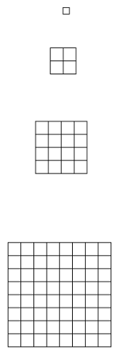
Drawing on Wynter (1971), we argue that assessment systems in teacher education are part of a plantation infrastructure and that alternative assessment strategies, while they diverge from testing paradigms, remain part of the plot architecture that enables the plantation to persist. In other words, the grid-based logics that drive colonial systems of education continue to be re-enforced in alternative assessment practices. Thus, a refocusing of attention towards a broadened multi-dimensional conceptualization of assessment might act as a framework for re-imagining assessment and guide practitioners in their planning for assessment tasks. First, we will discuss where we see these entanglements (read firm knots) between assessment practice and Wynter’s plantation infrastructure.
The dominant aim of the plantation is exchange-value. In contrast, that of the plot—its coeval adjunct—is use-value. We employ use-value to mean meeting the interrelated needs of survival, transcendence, dignity, belonging, and challenge (Khan, 2020; Tran et al, 2020). Existing in the shadow of the plantation, plots are sites of resistance and emergence of (re)new(ed) culture as well as of deep curatorial care (Forbes, 2010; Khan et al., 2022). The space where assessment intersects with speculative writing is in imagining ways that are “Other wise”—this is our plot. Alternative assessments, we believe, function as plots for teachers—spaces where one can produce what one needs to survive, places of hope, and places from which new cultural assemblages emerge. But a plot is ultimately not a place of freedom: working a plot does little to unsettle or disrupt the infrastructure logic or ongoing functioning of the plantation and its extractive-exploitative export-for-profit oriented modus operandi. For this, revolution, not evolution, is the only successful historical precedent we have. Following Wynter (2015) the work needed involves first a re-enchantment with minority discourse, or as we have framed it, seizing all opportunities to dream first and tell more hopeful stories.

A Speculative Method: Dream First, Negotiate Later
I (Stéphanie) find myself approaching ideas for my teaching without considering the constraints in implementing them. Initially, I thought that may be irresponsible. After all, should I not make sure my ideas will ‘fit’ with current institutional practices? I came across an affirming quotation: “we must first dream and think differently ideologically, even if it seems abstract or against the grain, before we can act upon our ideas and seek to implement alternative visions for the future” (Eizadirad, 2019, p. 203). For me, this is a suggestion that we must dream first and negotiate later.
The “dream first” part of our heuristic principle aligns well with speculative writing: we first consider an alternative to current assessment practice. What values, ideals and practices do we want to bring forward? The second part—“negotiate later”—attends to the question: To what flexibilities, tensions and contradictions do we have to attend? Dreaming first and negotiating later prevents researchers and practitioners from getting stuck in fossilized systems of practice. We find that alloying dream languages with speculative fiction is a productive path.
SpecQ3: With respect to assessment practices in your area of expertise, what are you dreaming about?
In the next section, we begin our process of re-enchanting assessment. We present a fractal model that emerged from Stéphanie’s dreaming and negotiation and functions as the first part of our plot.

Re-Enchanting Assessment
Figure 2 illustrates an imagined promising ‘future point’ for assessment practice. I (Stéphanie) hesitate to call it an endpoint. Assessment practice is not a fixed phenomenon; just as any pedagogical practice, it must always be in revision to maintain a reflexive practice. At the same time, I use the term future point to mean temporally far, a possibility that lives outside of current norms of practice—an estranged practice that diverges from the present and presents a possibility for the future.
Figure 2
Assessment Interactions as Embedded Within the Assessment Practice

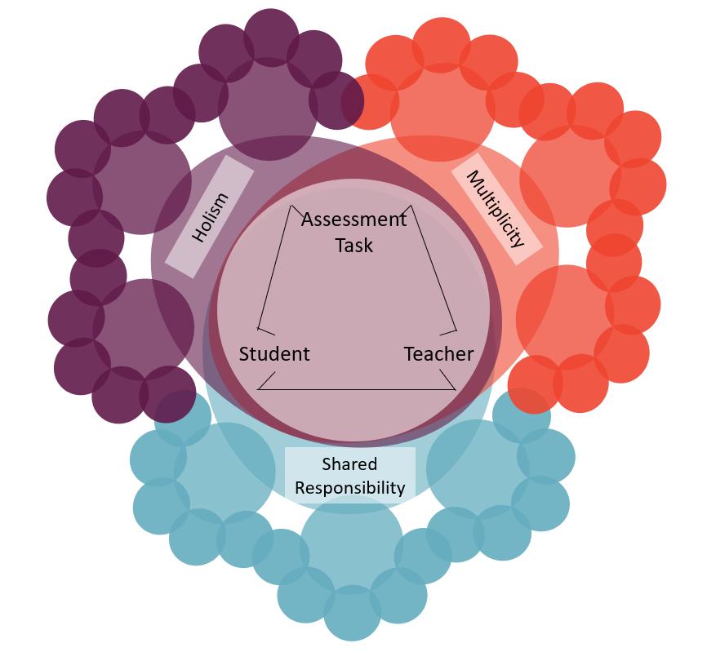

Fractal Model for Assessment
In La France (2021), I explored an imagined future assessment practice following the dream first, and negotiate later philosophy. I delved into the barriers I faced in implementing my perception of promising assessment practice. These are the disenchanting realities that are omitted, transformed, or mutated (Reid, 2009; Thomas, 2013) to re-imagine alternatives. I chose to engage in a thought experiment (dream) where standardized testing, grading, and the Program of Studies (PoS) no longer guided the planning and design of classroom assessment tasks or practice.
A common maxim in education is “planning with the end in mind” (Holm, 2018), which in my case means planning with the Alberta PoS in mind. By engaging in speculative practice, we are faced with the question: What ends do we have in mind? I re-present the speculative definition of assessment practice from La France (2021):
Assessment is a continuous and dynamic process and practice of sitting beside one another and co-creating evidence of learning mathematics in a way that contributes positively to the strength, wellness, value and worth of the student, the students’ learning, and the discipline of mathematics (La France, 2021, p.16, italics in original).
Using this framing of assessment as a starting point, what emerged was a three-dimensional fractal framework: holism, multiplicity and shared responsibility in assessment practice. The overlap of these three qualities provides a context in which to design and deliver assessment tasks (Figure 2). I examine each aspect individually.

Figure 3
A Fractal Representation of Holistic Assessment Practice
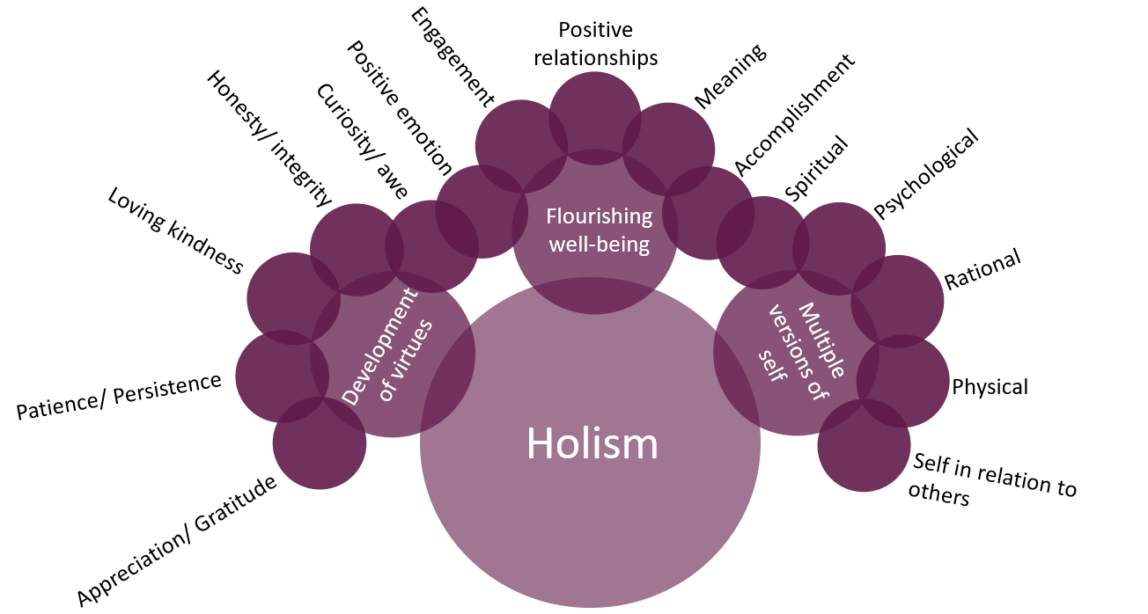
The main characteristic of holistic assessment practice is attention to the nuances of the whole student, whole context, and whole environment. Holism in assessment practice reframes assessment in terms of the ways in which identities are continuously negotiated in contrast to the more traditional practice of identity negation and nullification within mathematics assessment environments (e.g., Golson & Wilkes, 2017). Speculatively, it is about providing spaces in which the development of virtues (Su, 2020), flourishing and well-being (Seligman, 2011), and multiple versions of self are intentionally woven into the assessment environment (Figure 3).
SpecQ4: How might online spaces provide opportunity for human collaboration, connection, and creation within the context of holistic mathematics assessment?

Figure 4
A Fractal Representation of Multiplicity in Assessment Practice
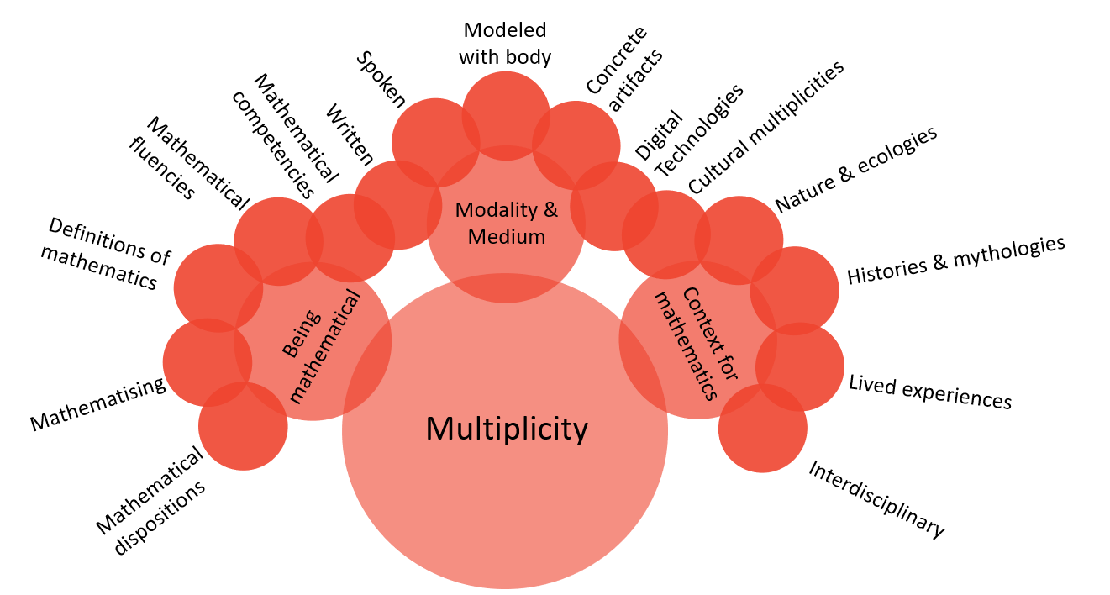

The dimension of multiplicity (Figure 4) engages with the multiple ways of being mathematical in a sense of broadening the scope of mathematical doing as a way of knowing (Mason, 2002), multiple modalities and media for doing mathematics (Kress, 2009), and multiple contexts and (his)tories within which and for which mathematics might be relevant (Joseph, 2011). It requires an engagement with an assessment practice that is innately pluralistic in content and in process. The contexts for learning mathematics could involve engaging with mythologies, ecologies, cultural practices, interdisciplinary practices, or sociological phenomena as in critical (Skovsmose, 2008), ethnomathematical (D’Ambrosio, 2001), and mythopoetic approaches to mathematics education (Khan, 2011).
SpecQ5: What multiplicities might we engage with in assessment practice? Where might there be spaces for plural engagements with and through mathematics?
Figure 5
A Fractal Representation of Shared Responsibility

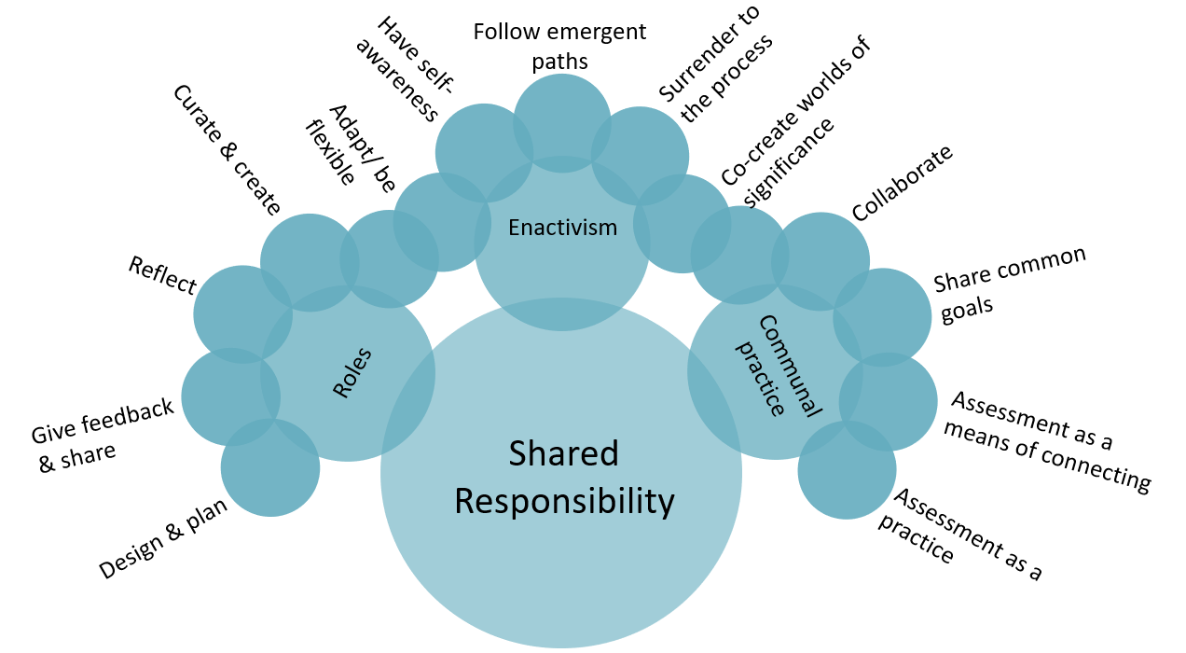
The final dimension, shared responsibility (Figure 5), refers to the communal nature of assessment practice. The roles and responsibilities, the conversations and interactions, and the shared goals are all elements of this dimension. If we imagine assessment as a communal activity (Brink, 1997) with a shared goal that is both holistic and multiplistic, the necessary result is a shift from teacher-centered to student- or community-centred orientations. There are multiple pieces to consider in the planning, delivering and inference-making processes in assessment, each of which involves particular roles and responsibilities. If the assessment practice is to be shared as a communal endeavour, then these enactments ought to be shared amongst those who are involved.
SpecQ6: Who ought to plan, design, give feedback, share, reflect and adjust, or curate and create?
Exemplifications
In summer and fall 2019, we began plotting an optional final-year course for pre-service elementary teachers and a parallel course for graduate teachers with the theme “Mathematics for Multispecies’ Flourishing” (see Khan et al., 2022; Tran et al., 2022). Multispecies flourishing brings together work that positions flourishing and learning how to promote flourishing as an explicit end for education (Cherkowski & Walker, 2018; Seligman, 2011) with work on the ways that human flourishing is always and everywhere tied up with the well-being of other species. Following Wynter (2005), the idea was to try to enact a more human genre of what it might mean to do and teach mathematics in K–8 classrooms in ways that troubled plantation logics and Man’s pandemic genres. Figure 6 is a copy of the wording in the course outline that provided the first invitation.

Figure 6
Course Outline Description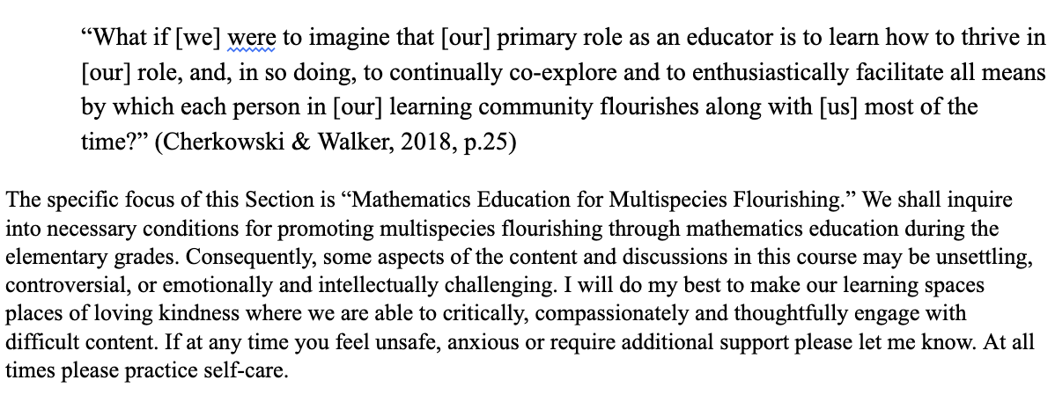
We imagined a mathematics assessment practice as being an interactive, polylogical/polyvocal/polyrhythmic ethical space in which we attend to the dignity, belonging, transcendence and survival of both ourselves as humans and the broader implications of mathematics on our living others. The realities of current assessment practices in mathematics are rich in colonial logics and language, and dispossess the multiplicities of mathematical doing, (en)coding and conceptualizing, storytelling, situating of place, and living experiences.
The framework informed our choice of content and experiences with learners. Our design was complex from the get-go with spaces intentionally left for emergence and the differential pace of learners’ sense-making with ongoing recursive elaboration. The learning in the course was assessed using elements of holism, multiplicity, and shared responsibility (see Table 1) with an expectation of a demonstration of more than minimal competence (though we did not use the model explicitly at that time).

Table 1
Assignments from EDEL 415 Winter 2020
Assignment | Weight
Curated professional growth and creativity/play journal including responses to weekly Tasks/Prompts/Activities/Readings. | 2 | Individual based on collective / communal experiences
Remixing of Open Education Resource | 2 | Group
Elementary Mathematics Education for Multispecies Flourishing Research/Speculative Essay. | 2 | Individual / Group
Exit Interview | 2 | Individual

We draw attention to the curated professional journal which best exemplifies the most aspects in an easily communicable way. Curation is intentional: more than just another ‘reflection,’ it was intended to be about things learners came to care about. We take one example—the making of paper fractal snowflakes (Figure 7) led by an invited community artist, Mary Spytz—which illustrates many of the aspects of the fractal framework in providing opportunities to develop and bear witness to multiple dimensions of holism, multiplicity and shared responsibilities. Figure 8 is sampled from a learner’s curated professional journal on the snowflake-making class.

Figure 7
Making Paper Fractal Snowflakes
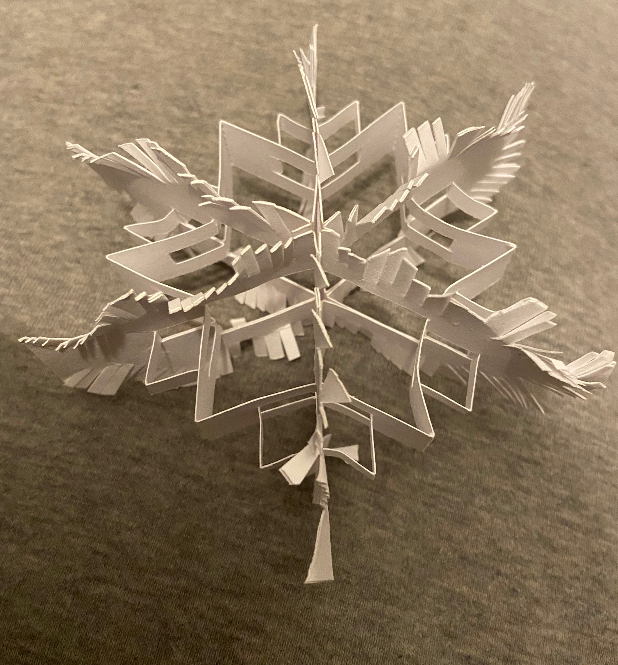

Figure 8
Sample From Curated Professional Journal
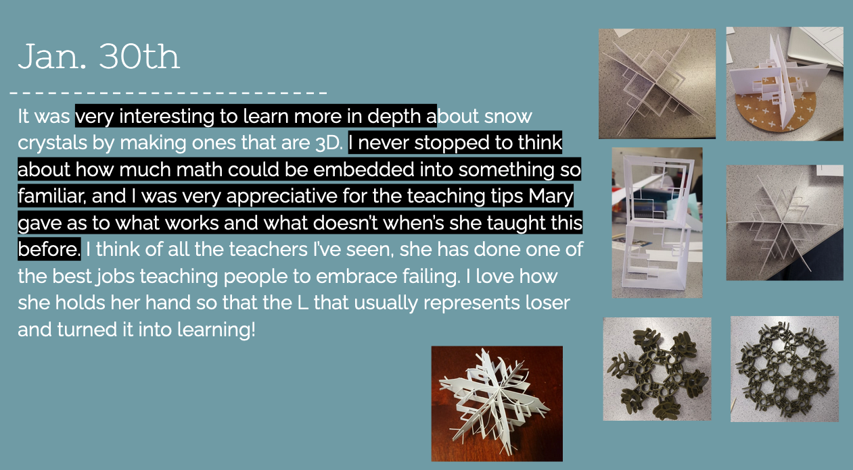
In the curation slide (Figure 8), we see evidence of engaging in multiplicity throughout the task. There were multiple modes present, such as discussing throughout the task, working with the body (hands, eyes, breath) to fold the paper and put together the LuxBlox materials, writing (or rather, typing) as a reflection of the task, and creating a visual representation of the task. These modes were engaged through multiple mediums such as paper, luxBlox, Google Slides and whatever the student was using to take pictures. The context for learning mathematics is “something so familiar” suggesting that this activity places mathematics within a particular context rather than learned through abstract mathematical modelling/calculation.
An indication of holism in the task is an expression of awe as the student re-experiences a familiar context from a mathematical perspective thus humanizing the task. Similarly, the phrase “she has done one of the best jobs teaching people to embrace failing” interrupts normative expectations for intellectual elitism and muddles the perceived (and oftentimes expected) linearity of mathematics. It suggests the development of virtues such as patience and compassion and alludes to a flourishing that is independent of intellectual success. Another phrase “I love…” in combination with the general ‘feel’ of the reflection, introduces an emotional self, the virtue of appreciation, and overall sense of wellness with and through the task.
Finally, as we look to the third dimension of the framework—shared responsibility—we see many actors in the task. Directly, we see Mary, the student, and the snowflake, all with active roles within and during the task. Indirectly, we see Steven and other students who would have been with this student during the task and during the reflection on the task. The open-endedness of the task means that the student writes their own story about the experience; they are the guide that invites Steven as the instructor into their understanding and experience of mathematical activity. During this task, the students and instructors were physically together in a room.
For another teacher candidate, the fractal cards provided an opportunity to explore mathematics more and begin initial speculation, which served as inspiration for and was taken up in their speculative inquiry final task around mandalas with pattern blocks. This was undertaken at home during the first mandated COVID-19 university closure. Later, this teacher emailed to say they had used the task they developed with learners in classrooms after finally emerging from the pandemic to good effect.
The images in Figure 9 are from the same teacher candidate’s final assignment which asked them to engage in a speculative lesson that they believed would contribute to their flourishing during the pandemic period and afterwards.
Figure 9
Images From Final Assignment
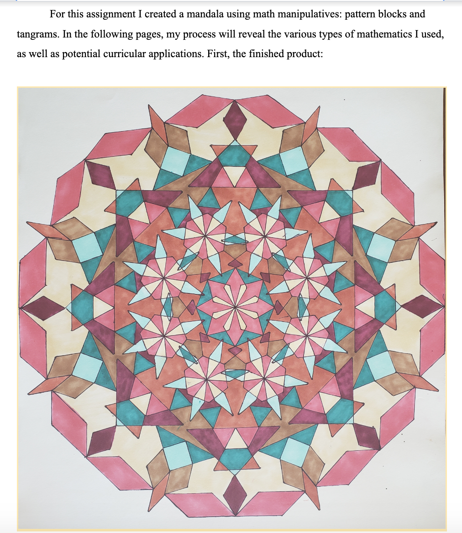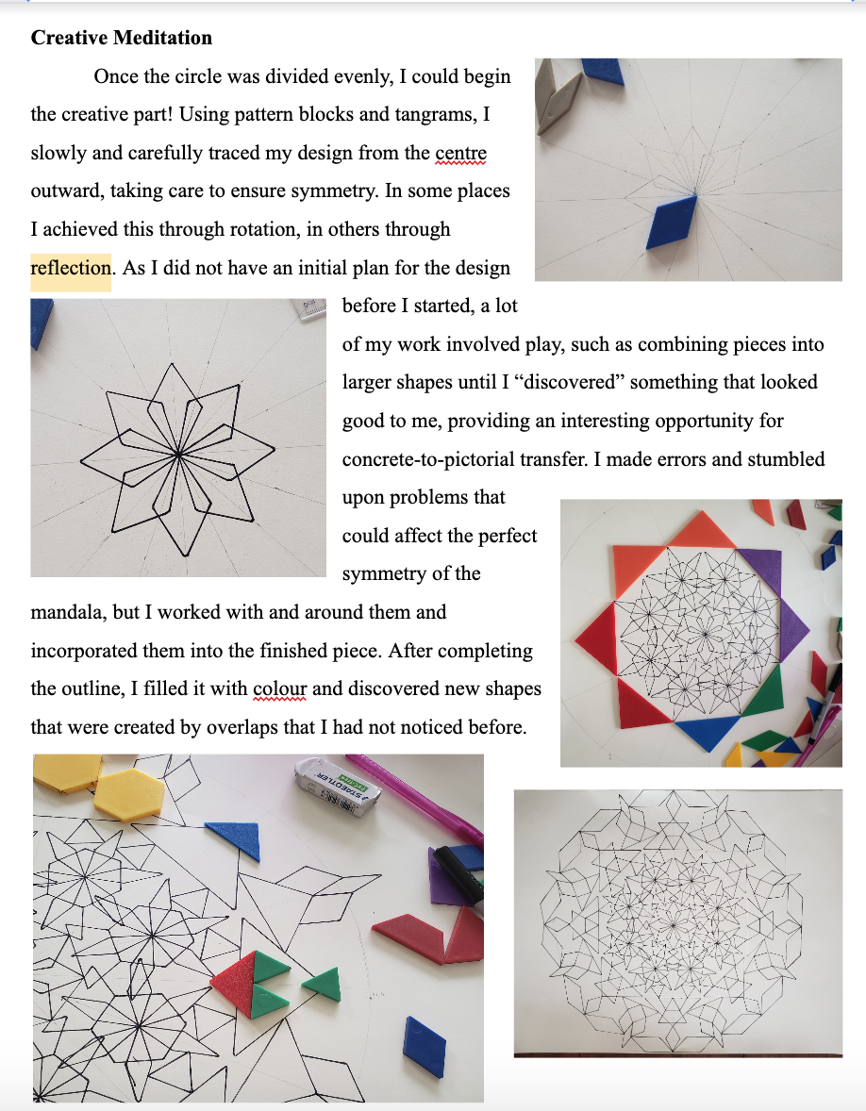

The opportunity to dream first and negotiate later worked in this instance with the teacher candidate having an opportunity to bring this into their own practice during the pandemic. In late 2021, I (Steven) received an email from the teacher-candidate whose work is shown in Figure 9 sharing a Mandala math art project that they did with their students around transformation and angles that grew out of their final assignment, and which linked back to this moment in the course.
This speculative assignment blurred the lines between mathematics and art enabling mathematics as beauty. The assignment was titled “Creative Meditation” suggesting that one engages in the task wholeheartedly with mind, body, heart, and soul. The task elicits layers of meaning-making across disciplines such as mathematics, art, anthropology (Mandala making as cultural ceremony) and psychology (Mandala making for healing). Something striking is that one senses the human connection with and through the task even if one were not physically present with others.
A final note in relation to the shared responsibility: this final assignment was open-ended. The student was responsible for choosing and developing an assignment that would best showcase their learning in the course. It is interesting to note that this transcends into when the assignment itself would be given to their elementary students as they began their teaching career. This task is an example of an activity that is both communal and collaborative. It sets the tone for connection and meditation through and with mathematics.

Assessment for Hope
Propaedeutic: I’ve never had a course that was so focused on the process and not the product. You constantly urged us to find something that would be personally meaningful going forward. That style alone was refreshing and will impact the way I teach. I want students to be impacted by their education and find aspects that are of genuine interest to them even if they aren’t perfectly refined at any one moment (Teacher candidate).
The frameworks we have presented above are a step towards ‘the dream’ in the sense that they present what we feel are important futures to pursue. While there are moments of alignment between the above example and the framework suggested above, we wish to refrain from within current institutional realities. While it is tempting to present concrete examples of assessment tasks and methods that would align well with these frameworks, presenting such examples would risk one or both of two things: (1) rob the reader of imagining and re-enchanting, for themselves; and (2) pompously suggest an ‘answer’ of sorts, rather than enabling a common journey to better practice. In this section, instead of proposing a specific assessment method to try, we suggest how one might begin to move one’s assessment practice forward in hope. That is, instead of something (noun) specific, we suggest how (verb) one might begin to try.
Re-enchantment is about choosing for oneself a more hopeful future, all the while engaging reflexively in practice so as not to (re)produce an assessment practice that once again serves plantation logics and economics. As we move forward in our assessment practice, making small adjustments here and there but always in the direction of our imagined ideal, we would note these small adjustments in action and explore the multiple interpretations and outcomes of those actions. We assess and reassess our assessment methods mindfully in practice.

In our work in Winter 2020 we modelled what it meant to show up with your whole being (Steinhauer et al, 2020) and we too have shifted how we treat the humans we are privileged to interact with as instructors or teachers. The teacher candidate quoted speaks to an experience and developing awareness of the value of honouring the process of learning over the product. This is something that we think transcends the type of learning situation -whether physical or virtual.

Conclusion
In this paper, we began with a dialogue about the more discouraging aspects of our lived experience as educators. Many of these disenchantments are intensified by their implicit threat to educator agency. We find ourselves stuck in particular realities where the structures in place act as barriers to implementing what we perceive as more meaningful, ethical, equitable and hopeful assessment practice. We suggest that using speculative fiction as a mode of pedagogical inquiry enables educators to imagine beyond immediate barriers by dreaming first and negotiating later. SF provides an avenue for curating a perceived ideal future for assessment without the constraints of current institutional realities and without immediate risk. We have provided an assessment framework and an example of this method of inquiry and suggest that this is a mode of salvaging hope and re-enchanting assessment practice.

References
Aikenhead, G. S. (2017). Enhancing school mathematics culturally: A path of reconciliation. Canadian Journal of Science, Mathematics and Technology Education, 17(2), 73-140. doi: 10.1080/14926156.2017.1308043
Alexander, N. A. (2019). Daija's awakening: Critical race theory and Afrofuturism in Mathematics Education. In J. Davis & C. C. Jett (Eds.) Critical Race Theory in Mathematics Education (pp. 56–74). Routledge.
Brooker, M. K., & Thomas, A-M. (2009). Science fiction in western culture. In The science fiction handbook (pp.). West Sussex, UK: John Wiley & Sons, Incorporated.

Cherkowski, S. & Walker, K. (2018). Teacher wellbeing. Noticing, nurturing and sustaining flourishing in schools. Ontario: Canada, Word & Deed Publishing.
Ciastellardi, M. & Di Rosario, G. (2015). Transmedia literacy: A premise. International Journal of Transmedia Literacy 1(1), 7-16. doi: 10.7358/ijtl-2015-001-cias
de Freitas, E. (2008). Mathematics and its other: (dis)locating the feminine. Gender and Education, 20(3), 281–290. doi: 10.1080/09540250801964189
de Freitas, E., & Truman, S. E. (2021). New Empiricisms in the Anthropocene: Thinking With Speculative Fiction About Science and Social Inquiry. Qualitative Inquiry, 27(5), 522–533. https://doi.org/10.1177/1077800420943643
Davis, B., & Simmt, E. (2003). Understanding learning systems: Mathematics education and complexity science. Journal for Research in Mathematics Education 34(2), 137-167. doi:10.2307/30034903
D’Ambrosio, U. (2001). What is ethnomathematics, and how can it help children in schools? Teaching Children Mathematics 7(6), 308-310. doi:10.5951/TCM.7.6.0308
Dillon, G. & Marques, P. N. (2021). Taking the fiction out of Science Fiction: A conversation about Indigenous Futurisms. e-flux, 120, https://www.e-flux.com/journal/120/417043/taking-the-fiction-out-of-science-fiction-a-conversation-about-indigenous-futurisms/
Donald, D. (2020, January 28). Dwayne Donald - Homo economicus and forgetful curriculum: Remembering other ways to be a human being [Recorded Presentation]. https://www.youtube.com/watch?v=VM1J3evcEyQ&feature=youtu.be
Doolittle, E. (2018). Off the grid. In S. Gerofsky (Ed.) Contemporary environmental and mathematics education modelling using new geometric approaches (pp. 101-122). Springer
Eizadirad, A. (2019). Decolonizing educational assessment models. In Decolonizing educational assessment: Ontario elementary students and the EQAO (pp. 203–228). Palgrave Macmillan. https://doi.org/10.1007/978-3-030-27462-7

Ellsworth, E. (2004). Places of Learning: Media, Architecture, Pedagogy (1st ed.). Routledge. https://doi.org/10.4324/9780203020920
Forbes, C. (2010). Between plot and plantation, trespass and transgression: Caribbean
migratory disobedience in fiction and internet traffic. Small Axe, 38, 23-42. DOI 10.1215/07990537-1665659
Gholson, M. L., & Wilkes, C. E. (2017). (Mis)Taken Identities: Reclaiming Identities of the “Collective Black” in Mathematics Education Research Through an Exercise in Black Specificity. Review of Research in Education, 41(1), 228–252. https://doi.org/10.3102/0091732X16686950
Holm, J. (2018). Planning a unit by starting with the end in mind: Unit and lesson planning. In A. K. Kajander, J. Holm, & E. J. Chernoff (Eds.), Teaching and learning secondary school mathematics: Canadian perspectives in an international context (pp. 441–452). Springer International Publishing. https://doi.org/10.1007/978-3-319-92390-1
Joseph, G. G. (2011). The crest of the peacock: Non-European roots of mathematics (3rd Edition). Princeton University Press.
Khan, S. K. (2020). After the M in STEM: Towards Multispecies’ Flourishing. Canadian Journal of Science, Mathematics and Technology Education, 20, 230–245. https://doi.org/10.1007/s42330-020-00089-4
Khan, S. K., LaFrance, S. & Tran, H. T. T. (2022). After plantations’ precarities: Curating
math-thematic curriculum plots in initial teacher education for multispecies’ flourishing and a freedom-yet-to-come. Research in Mathematics Education 24(4), https://doi.org/10.1080/14794802.2022.2090421
La France, S. A. (2021). Engaging in speculation and critical reflection about future assessment
practice. Unpublished M.Ed. Thesis, University of Alberta, Edmonton, Canada.

Little Bear, L. (2000). Jagged worldviews colliding. In M. Battiste (Ed.), Reclaiming Indigenous voice and vision (pp. 77-85). UBC Press. https://www.deslibris.ca/ID/404356
Mason, J. (2002). Researching your own practice: The discipline of noticing. RoutledgeFalmer. https://doi.org/10.4324/9780203471876
Pai, J. (2018). Observations and conversations as assessment in secondary mathematics. In D. R. Thompson, M. Burton, A. Cusi, & D. Wright (Eds.), Classroom assessment in mathematics: Perspectives from around the globe (pp. 25–42). Springer International Publishing. https://doi.org/10.1007/978-3-319-73748-5
Reid, M. (2009). Postcolonialism. In M. Bould, A. M. Butler, A. Roberts, & S. Vint (Eds.), The Routledge companion to science fiction (pp. 256–266). New York, NY: Routledge.
Seligman. M. P. (2011). Flourish: A visionary new understanding of happiness and well-being.
Simon & Schuster
Simmt, E., & Kieren, T. (2015). Three “moves” in enactivist research: A reflection. ZDM, 47(2), 307–317. https://doi.org/10.1007/s11858-015-0680-09
Singh, J. (2018). Unthinking mastery: Dehumanism and decolonial entanglements. Duke University Press. http://library.oapen.org/handle/20.500.12657/30252
Steinhauer, E. et al. (2020). Thinking with Kihkipiw: Exploring an Indigenous theory of assessment and evaluation for teacher education. In Cote-Meek, S. & Moeke-Pickering, T (Eds.), Decolonizing and Indigenizing education in Canada (pp. 73–90). Canadian Scholars.
Skovsmose, O. (2008). Mathematics education in a knowledge market: Developing functional and critical competencies. In L. deFreitas, & K. Nolan (Eds.), Opening the Research Text: Critical insights and in(ter)ventions into mathematics education (pp. 159–174). Springer. https://doi.org/10.1007/978-0-387-75464-2
Su, F. (2020). Mathematics for Human Flourishing. Yale University Press.
Suurtamm, C. (2018). Enhancing mathematics teaching and learning through sound assessment practices. In A. K. Kajander, J. Holm, & E. J. Chernoff (Eds.), Teaching and learning secondary school mathematics: Canadian perspectives in an international context (pp. 472–482). Springer. https://doi.org/10.1007/978-3-319-92390-1
Talbert, R. (2022, June 13). What to do before you do alternative grading. Grading for Growth. https://gradingforgrowth.com/p/what-to-do-before-you-do-alternative?s=r&fbclid=IwAR0vzXCdfyNAopjZmcK1neWm2y0qIvJLiY7RyMWOVSKl69fC2na7CnBcmtw
Thomas, P. L. (2013). A case for SF and speculative fiction: An introductory consideration. In P. L. Thomas (Ed.), Science fiction and speculative fiction: Challenging genres (pp. 15–33). Sense Publishers. https://doi.org/10.1007/978-94-6209-380-5
Thorne, Syd, "Through Critique and Beyond: Speculative Fiction as a Tool of Critical Pedagogy" (2021). Master's Projects and Capstones. 1288. https://repository.usfca.edu/capstone/1288
Truman, S. E. (2021). Theoretical precursors: Tracing my methodology for research-creation. Feminist speculations and the practice of research-creation: Writing pedagogies and intertextual affects (pp. 1–30). Routledge. https://doi.org/10.4324/9781003104889
TODOS (Producer). (2020, May 17). Episode 10: Rethinking assessment with Amanda Ruiz and Vanson Nguyen [Audio podcast]. https://todosmath.podomatic.com/
Van Dooren, T., Kirksey, E. & Münster, U. (2016). Multispecies studies: Cultivating arts of attentiveness. Environmental Humanities, 8(1), 1–23. https://doi.org/10.1215/22011919-3527695
Wynter, S. (1971). Novel and history, plot and plantation. Savacou, 5, 95–102.
Wynter, S (1984). The ceremony must be found: After Humanism. boundary 2, 12(3), 19-70.
https://doi.org/10.2307/302808
Wynter, S. & Scott, D. (2000). The re-enchantment of Humanism: An interview with Sylvia
Wynter. Small Axe 8, 119-207
Wynter, S. (2015). The ceremony found: Towards the autopoetic turn/overturn, its autonomy of
human agency and extraterritoriality of (self-)cognition. In J. R. Ambroise & S. Broeck (Eds.), Black knowledges/black struggles: Essays in critical epistemology (pp. 185-252). Liverpool Scholarship Online. https://doi.org/10.5949/liverpool/9781781381724.003.0008 594

PhD student. Please direct inquiries to stephlaf@student.ubc.ca
This is important as instructors have more freedom and flexibility to function as designers and curators with optional courses in terms of content, experiences and assessment. I did lean on and borrow from my colleagues who had taught this course previously and likewise paid it forward by passing on resources and ideas to the next instructor to make it their own with students.

